**HTML5 Form Validation**

**novalidate**

**novalidate attribute is used in form tag to disable HTML5 based Form validation. After using novalidate in form tag, required and type based validation will not work.**

**<form novalidate>**

**<input type="text" required>**

**<input type="submit">**

**</form>**

**autofocus**

**autofocus attribute focus on that single particular form control on page load. autofocus can be used only once in a single webpage. It supports only the following elements: <button>, <input>, <select> and <textarea>.**

**placeholder**

**placeholder attribute shows some hint in input control. Placeholder value will disappear on focus or keypress. Supported controls for placeholder are input controls and textarea. The default color of placeholder is lightgray, i.e (#999).**

**<form>**

**<input type="text" placeholder="Enter Name" required >**

**</form>**

**required**

**required attribute is a boolean attribute used to add validation in form controls like inputs, textarea, radio controls, checkbox and select dropdown. With required, a blank form control can not submit value.**

**Example1**

**<form>**

**<input type="checkbox" required >**

**</form>**

**Example2**

**<form>**

**<input type="radio" name="gender" required > Male**

**<input type="radio" name="gender" required > Female**

**</form>**

**Example3**

**<form>**

**<select required>**

**<option value="">--Choose City--</option>**

**<option>New Delhi</option>**

**<option>Chennai</option>**

**<option>Mumbai</option>**

**<option>Kolkata</option>**

**</select>**

**</form>**

**pattern**

**Create JavaScript regular expression for input controls and textarea. Regex can be used to validate pincode, debit/credit card no, cvv no, atm pin etc.**

**<input type="text" placeholder="Enter Pincode" required pattern="^[0-9]{6}$" title="Enter Valid Pin Code">**

**minlength and maxlength**

**Will submit a form only when this field is filled with minimum n characters.**

**<input type="text" placeholder="Enter Name" required minlength="3" >**

**readonly**

**A control with readonly attribute is not editable by user.**

**<input type="text" value="India" readonly>**

**min , max,step attributes**

**Select Range Number between 10 to 100**

**<input type="number" min="10" max="100" step="2"/><br>**

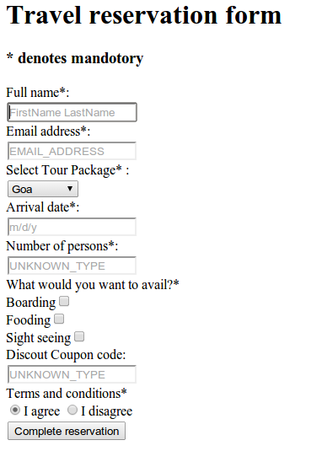

**Example**

**<!DOCTYPE html>**

**<html>**

**<body>**

**<form action="/action_page.php" method="post">**

**<label>Enter your name**

**<input type="text" name="fname" required autofocus>**

**Enter Address**

**<input type="text" name="lname" required></label>**

**<p>**

**<label>Enter your mobile number**

**<input name="tel1" type="text" pattern="[0-9]{3}" placeholder="###" size="3"/>**

**<input name="tel2" type="text" pattern="[0-9]{3}" placeholder="###" size="3" />**

**<input name="tel3" type="text" pattern="[0-9]{4}" placeholder="####" size="4"/>**

**</label>**

**</p>**

**Select Range Number between 10 to 100**

**<input type="number" min="10" max="100" step="2"/><br>**

**Slider**

**<input type="range" size="2" name="st" min="1" max="10" value="3">**

**<input type="text" placeholder="Enter string" required minlength="3">**

**<input type="text" placeholder="Enter City Name" list="citylist" required >**

**<datalist id="citylist">**

**<option>New Delhi</option>**

**<option>Chennai</option>**

**<option>Kolkata</option>**

**<option>Mumbai</option>**

**</datalist>**

**<input type="submit" value="Submit">**

**</form>**

**</body>**